E-Commerce Product Review Analysis

Project Description:
E-Commerce Product Review Analysis is an advanced Natural Language Processing (NLP) project designed to analyze product reviews from online marketplaces and determine customer sentiment as well as product quality insights. The system processes large volumes of Amazon reviews and identifies whether a user’s feedback is positive, neutral, or negative, while also capturing important keywords related to product strengths and weaknesses such as battery life, performance, durability, pricing, and delivery issues. By leveraging sentiment analysis models, text preprocessing techniques, and TF-IDF vectorization, this system helps e-commerce businesses understand customer opinions, improve product offerings, and optimize decision-making for brands and sellers.

Project Scenarios:
Scenario 1: Product Quality Monitoring
A brand receives thousands of reviews for a new smartphone launch.
The system analyzes reviews in real time, identifying customer sentiments and extracting insights like:
- “battery life issue”
- “excellent camera quality”
- “slow delivery”
This helps the brand improve manufacturing and customer support.

Scenario 2: Customer Feedback Evaluation for E-Commerce Sellers
Small online sellers often struggle to manually review hundreds of product comments.
The system automatically classifies reviews into positive, negative, or neutral and summarizes repeated complaints, helping sellers make data-driven decisions.

Scenario 3: Automated Review Moderation
E-commerce platforms want to maintain quality and detect:

- fake reviews
- abusive language
- spam content
The model flags suspicious or low-quality reviews, enabling better moderation and user trust.

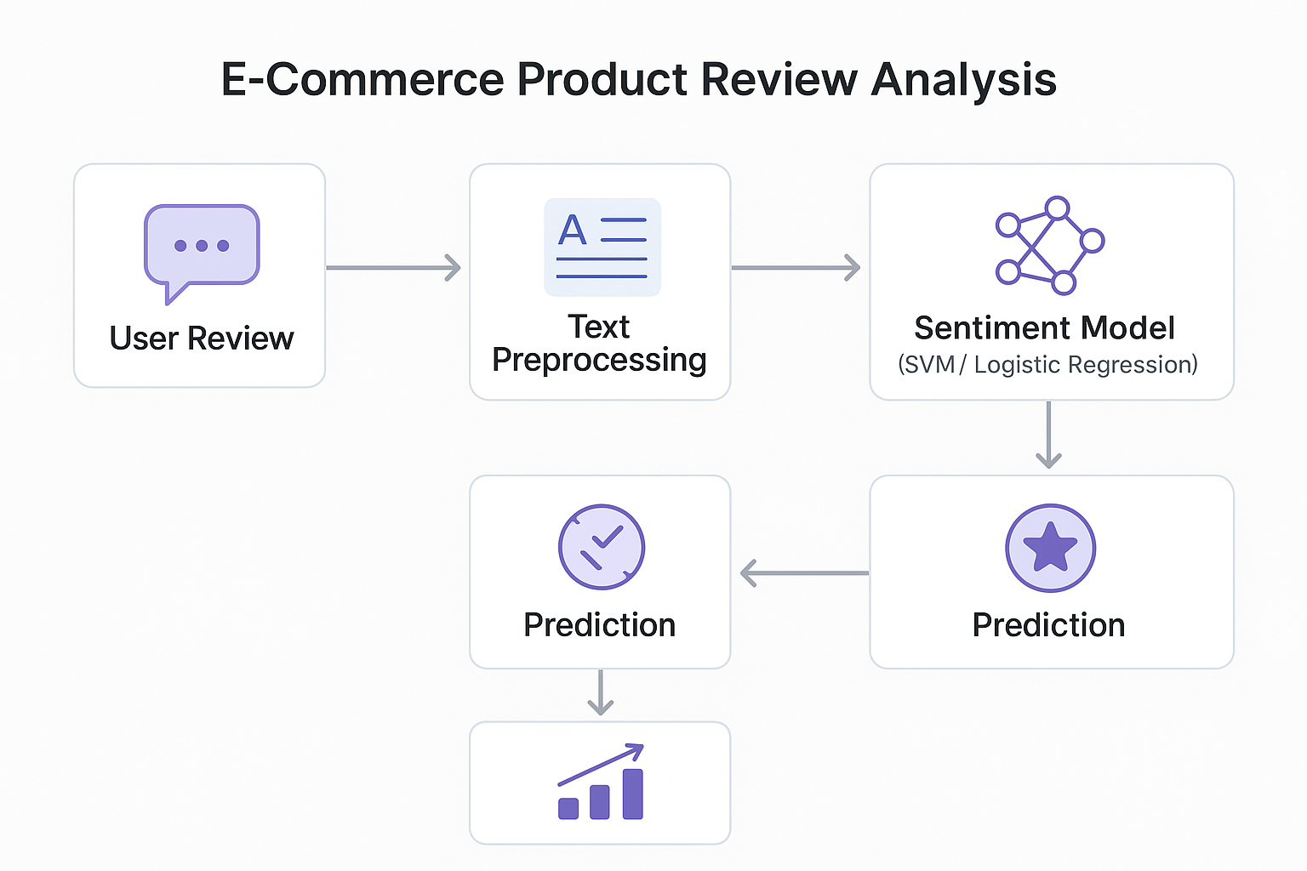
Technical Diagram:

Prerequisites:
To complete this project, the following tools and libraries are required:

Software Requirements
- Jupyter Notebook / Google Colab
- Python 3.x

Python Libraries
Install the following:
pip install numpy
pip install pandas
pip install nltk
pip install scikit-learn
pip install seaborn
pip install matplotlib
pip install wordcloud
pip install tqdm

Prior Knowledge
You should have basic understanding of:

NLP Concepts
Tokenization
Stopword Removal
Lemmatization
TF-IDF Vectorization
Sentiment Analysis

Machine Learning Algorithms
Logistic Regression
Support Vector Machine (SVM)
Naive Bayes
Random Forest
Evaluation Metrics

Visualization Skills
Seaborn plots
Word Clouds
Correlation heatmaps

Project Flow:
- User enters or uploads product reviews
- System preprocesses text (cleaning, tokenizing, lemmatizing)
- Features extracted using TF-IDF vectorizer
- Sentiment model analyzes processed review
- Output displayed as Positive, Neutral, or Negative
- System highlights key positive & negative keywords.

Project Activities :
1. Data Collection & Preparation
- Collect dataset (Amazon Reviews)
- Clean and prepare text data
2. Exploratory Data Analysis
- Word Clouds
- Review length distribution
- Sentiment distribution
- Frequency analysis
3. Model Building
- Train ML models
- Test multiple algorithms
4. Performance Testing
- Evaluate models
- Compare accuracy
5. Deployment
- Save model
- Connect to UI / API

Project Structure:

static/
Contains static assets (CSS, JavaScript, uploaded images)
○ style.css – Application styling

templates/
HTML templates for Flask application
○ index.html – Landing page for entering product reviews
○ result.html – Displays sentiment prediction and insights

app.py
Flask application backend

sentiment_model.pkl
Trained sentiment classification model file

tfidf_vectorizer.pkl
Saved TF-IDF vectorizer used for text feature extraction

GENAI_project.ipynb
Jupyter notebook with preprocessing, EDA, model training, and evaluation code

Dataset/
Contains the dataset used for training and testing
○ reviews.csv – Amazon product reviews dataset

Tree diagram:

Project/
├── static/
│ └── style.css
├── templates/
│ ├── index.html
│ └── result.html
├── app.py
├── sentiment_model.pkl
├── tfidf_vectorizer.pkl
├── GENAI_project.ipynb
└── Dataset/
└── reviews.csv

Milestone 1: Data Collection & Preparation
Data collection is fundamental to Natural Language Processing (NLP). It provides the raw text reviews required to train sentiment analysis models. The quality, quantity, and diversity of the dataset directly impact model performance
Activity 1.1: Collect the Dataset
- Collected Amazon product reviews dataset (reviews.csv).
- Dataset contains review text, user ratings, review titles, and derived sentiment labels.

Activity 1.2: Importing the Libraries
Essential Python libraries for text cleaning, NLP, and model building are imported
(Pandas, NLTK, scikit-learn, Matplotlib, Seaborn, WordCloud, etc.).

Activity 1.3: Read the Dataset : Loaded dataset using Pandas and inspected the first few rows to understand its structure.
Activity 1.4: Data Preparation
Performed text preprocessing including:
- Lowercasing
- Removing punctuation
- Removing stopwords
- Lemmatization
- Removing special characters
A new cleaned column was created: cleaned_text

Activity 1.5: Handling Missing Values
Checked for missing values and removed incomplete records to ensure quality.

Activity 1.6: Handling Duplicates
Removed duplicate reviews to avoid bias and redundancy in model training.

Activity 1.7: Checking for Outliers
Outliers were detected based on review length:
- Extremely short reviews (e.g., “good”, “bad”)
- Extremely long promotional/spam reviews
These were analyzed through boxplots and removed if necessary.

Milestone 2: Exploratory Data Analysis (EDA)
Exploratory Data Analysis is crucial to understand patterns in textual data. It helps guide the preprocessing strategy and model selection.
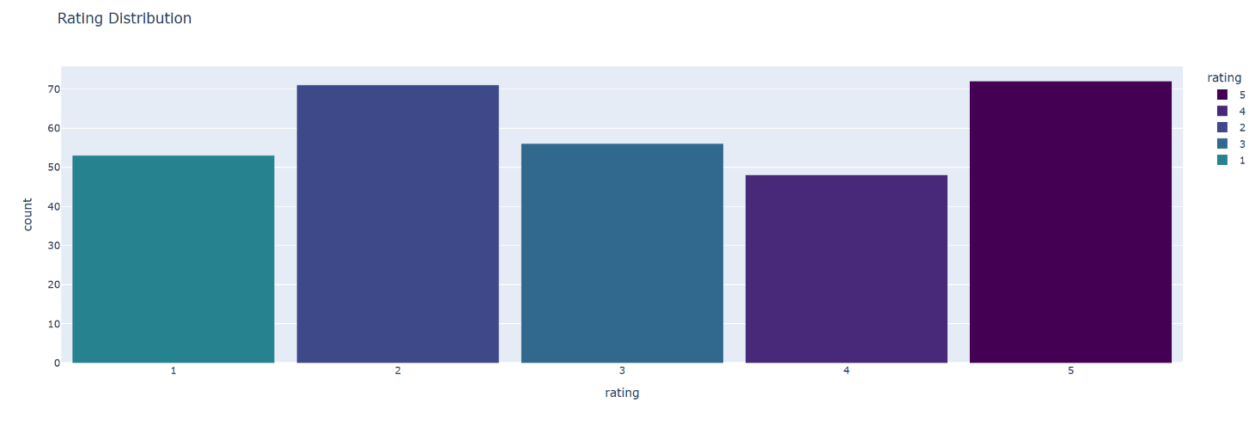
Activity 2.1: Descriptive Statistics
Basic statistics such as:
- Review length
- Sentiment distribution
- Rating distribution
were generated to understand dataset characteristics.

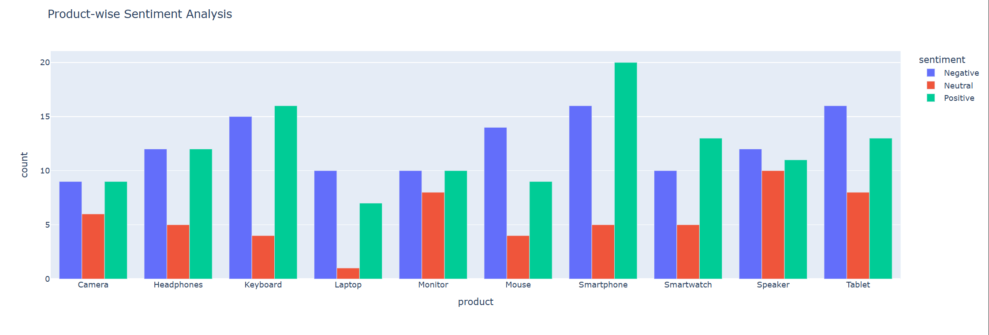
Activity 2.2: Visual Analysis
Generated visualizations including:
- Word clouds (positive/negative reviews)
- Rating-wise sentiment patterns
- Review length histograms
These visuals help identify recurring words and review quality.
Activity 2.3: Univariate Analysis
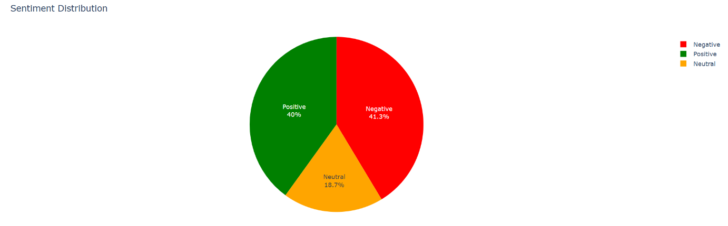
Studied individual features such as:
- Rating distribution (1–5)
- Sentiment counts (Positive / Neutral / Negative)
This helps detect class imbalance.

Activity 2.4: Bivari ate Analysis
Analyzed relationships between:
- Review length vs sentiment
- Star rating vs sentiment
This shows how textual features correlate with user feedback.

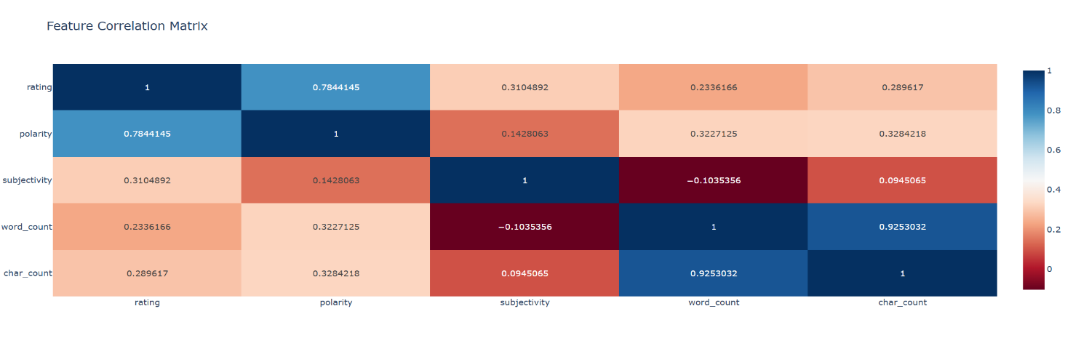
Activity 2.5: Correlation Analysis
Although text features cannot be correlated numerically directly, we computed:
- TF-IDF feature correlations
- Rating vs sentiment heatmaps
Activity 2.6: Pairplot / Word Associations
Performed:
- Keyword co-occurrence
- Bigram / trigram visualizations
- Word pair analysis
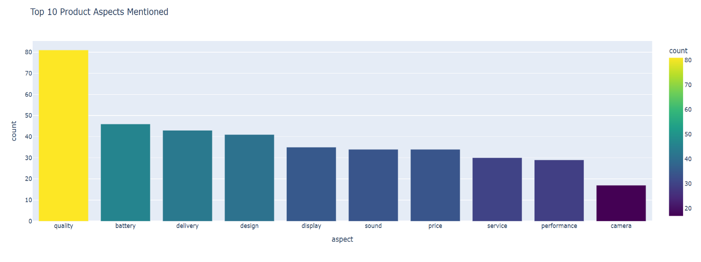
This reveals important repeated themes in reviews.

Milestone 3: Model Building
Multiple machine learning models were trained using the cleaned dataset and TF-IDF vectorized features.
Activity 3.1: Train-Test Split
Dataset was split into:
- 80% training data
- 20% testing data

Activity 3.2: TF-IDF Vectorization
Converted text into numerical features using TF-IDF to capture word importance.

Activity 3.3: Training Multiple Models
Trained the following classifiers:
- Logistic Regression
- Support Vector Machine (LinearSVC)
- Random Forest

Milestone 4: Performance Testing & Model Selection
Activity 4.1: Model Comparison
Each model was evaluated using:
- Accuracy
- Precision
- Recall
- F1-score
SVM achieved the highest performance on the test set.

Activity 4.2: Evaluation Metrics
Generated:
- Classification report
- Confusion matrix
- Sentiment-wise accuracy breakdown
This ensured the final model was robust and reliable.

Milestone 5: Model Deployment
Activity 5.1: Save the Best Model
Saved the following files:
- sentiment_model.pkl
- tfidf_vectorizer.pkl
These are used in deployment for real-time predictions.

Activity 5.2: Flask Web Application Development
A simple UI was developed with:
- index.html → Input review
- result.html → Displays sentiment output
The Flask backend:
- Loads the model
- Preprocesses the input review
- Generates sentiment prediction
- Displays result with confidence score

Backend Implementation (app.py)
The Flask backend is responsible for the core ML workflow:
Model Loading:
Loads tfidf_vectorizer.pkl and sentiment_model.pkl during application startup so that predictions can be made instantly without reloading the model on every request.
Data Handling:
Receives the review entered by the user through a POST request from index.html. The backend extracts the text field (review) and passes it to the preprocessing pipeline.
Preprocessing:
Applies the same text-cleaning steps used during training to ensure consistent feature representation. This includes:
- Lowercasing and noise removal
- Stopword removal.
- Converting the cleaned text into TF-IDF features using the loaded vectorizer
Prediction:
The processed TF-IDF vector is passed to the trained sentiment model.
Depending on the model type, the backend uses either:
- predict_proba()
- or decision_function() (for models like LinearSVC)
to generate the predicted sentiment and an associated confidence score.
Result Interpretation:
Maps the model’s output to human-readable sentiment labels (“Positive”, “Neutral”, or “Negative”) and computes a confidence percentage. The result is sent back to result.html, displaying:
- Original review, Cleaned review
- Sentiment prediction
- Confidence score
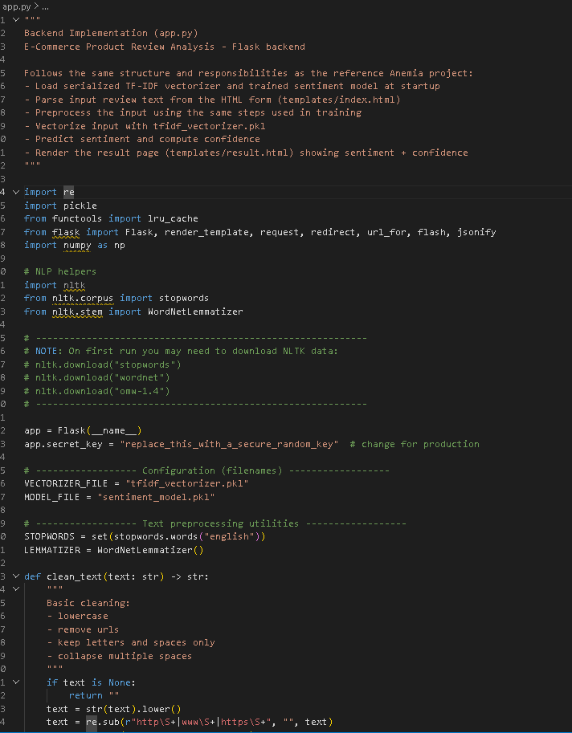

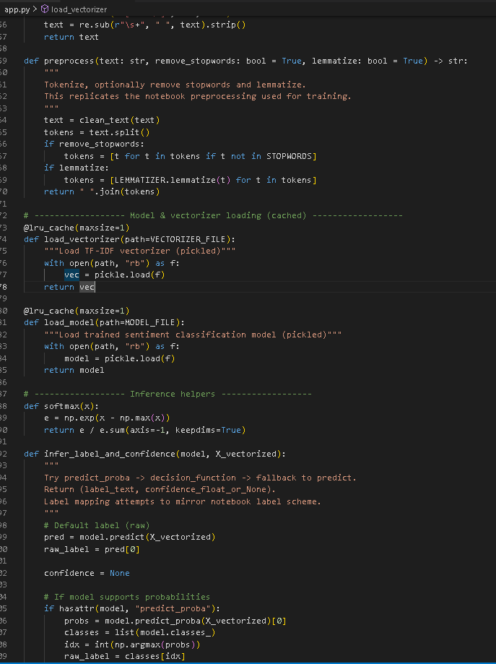
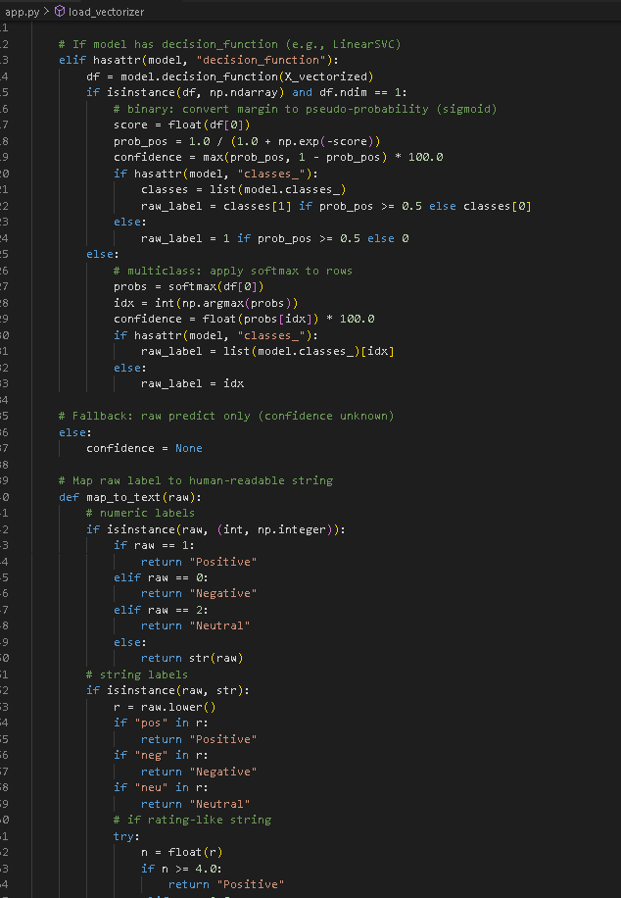
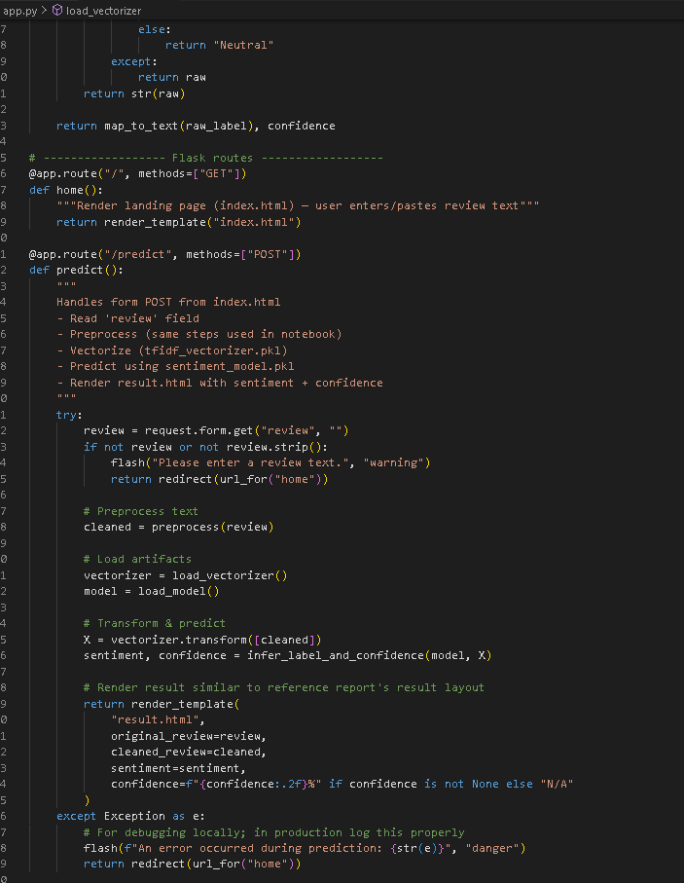
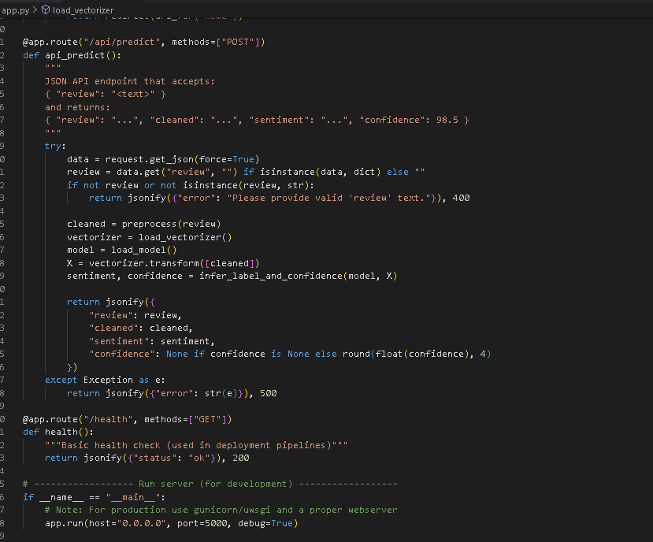
Frontend Implementation (HTML Templates)
The web interface for the E-Commerce Product Review Analysis system is designed to provide a clean and user-friendly experience for entering product reviews and viewing sentiment predictions.
Key Features of the Web Application:
- User Input Form (index.html):
  - Contains a text area where users can enter or paste an e-commerce product review.
  - Simple layout with clear instructions for submitting the review.
  - A single submit button sends the review text to the Flask backend via a POST request.
- Result Display Page (result.html):
  - Shows the predicted sentiment as: Positive, Neutral, or Negative.
  - Displays a confidence percentage (e.g., “94.72%”).
  - Shows both the original review text and the cleaned review used by the model.
  - Sentiment output is color-coded for better readability (e.g., green for Positive, red for Negative).
- Responsive Styling (style.css):
  - Ensures the interface looks clean and visually consistent.
  - Improves readability of results with neat spacing, typography, and modern UI colors.
  - Provides a centered layout similar to the reference project’s clinical interface.
- Safe Input Handling:
  - Validates user input before sending it to the backend.
  - Prevents empty submissions and displays warnings if the review field is blank.
- Workflow:
  - Users enter a review → click submit → backend processes → prediction is returned → user sees sentiment & confidence.

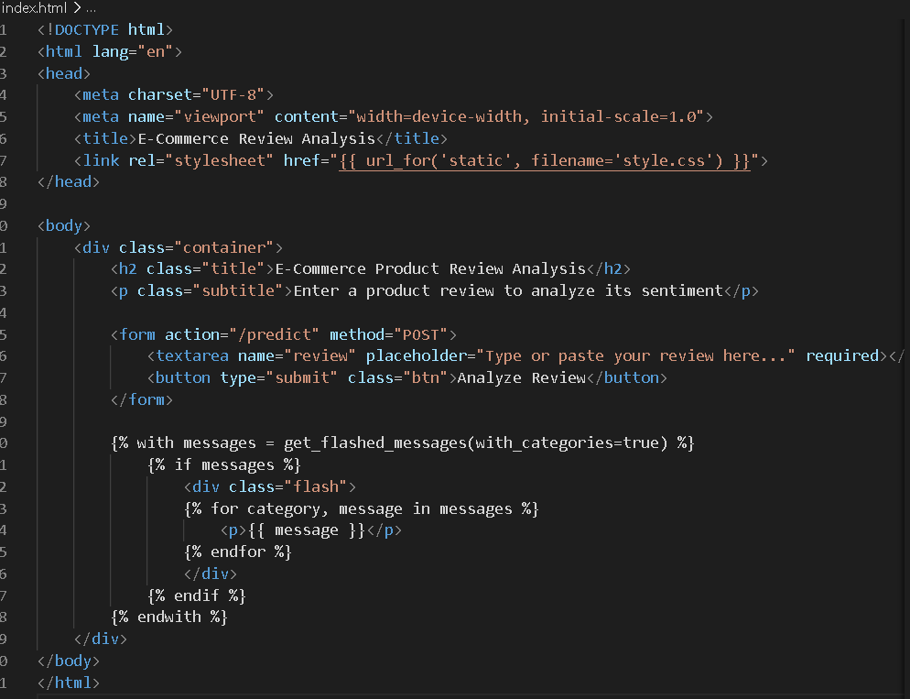
index.html :

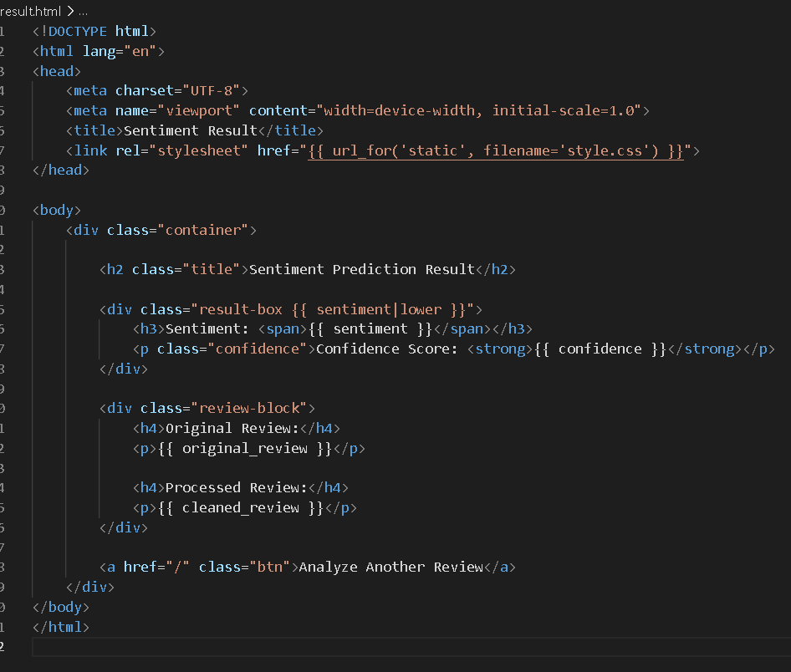
result.html :
Application Screenshots & Workflow
This section mirrors the style and layout of your reference report but adapted for E-Commerce Product Review Analysis.

Future Implementations
Future plans for the E-Commerce Product Review Analysis system focus on deployment, platform integration, and model enhancement:

E-Commerce Platform Integration:
Develop API endpoints to integrate the sentiment model directly with platforms like Amazon, Flipkart, and Shopify to automatically analyze new customer reviews.
Aspect-Level Insights:
Extend the model to detect sentiment for individual product aspects (e.g., battery, delivery, price, design) for more detailed feedback analysis.
Advanced Model Deployment:
Experiment with ensemble or transformer-based models (BERT, RoBERTa) to improve prediction accuracy and stability across diverse review categories.
Seller/Brand Dashboard:
Build a web dashboard for sellers to monitor real-time sentiment trends, negative review spikes, and product-specific issues.
Continuous Improvement:
Expand the dataset with reviews from multiple platforms and languages to make the model more robust, diverse, and globally applicable.

Conclusion
The E-Commerce Product Review Analysis system successfully demonstrates how Natural Language Processing and Machine Learning can be applied to interpret customer feedback at scale. By preprocessing review text, extracting TF-IDF features, and applying a trained sentiment classification model, the system accurately identifies whether a review expresses Positive, Neutral, or Negative sentiment.
The project provides valuable insights into customer opinions, product strengths, and areas needing improvement. Through the visualizations and analytics performed during EDA, the system highlights sentiment trends across product categories, ratings, and frequently mentioned aspects.
Overall, this solution serves as an efficient decision-support tool for sellers, brands, and e-commerce platforms. With future enhancements such as aspect-based sentiment analysis, multilingual support, and platform integration, the application can evolve into a powerful, real-time analytics system for large-scale customer experience monitoring.

